Software Requirements Specification
for
SCE CRM
Version 1.0 approved
Prepared by Group 4
Kesem Even Hen
Noy Nir
Elenaal Exceinko
Shai Idan
Yarin Edri
Matan Tal
David Ohana
Adam Yahnin
09.11.18
Table of Contents
Table of Contents ii
Revision History ii
1. Introduction 1
1.1 Purpose 1
1.2 Document Conventions 1
1.3 Intended Audience and Reading Suggestions 1
1.4 Product Scope 1
1.5 References 1
2. Overall Description 2
2.1 Product Perspective 2
2.2 Product Functions 2
2.3 User Classes and Characteristics 2
2.4 Operating Environment 2
2.5 Design and Implementation Constraints 3
2.6 User Documentation 3
2.7 Assumptions and Dependencies 3
3. External Interface Requirements 4
3.1 User Interfaces 8
3.2 Hardware Interfaces 8
3.3 Software Interfaces 9
3.4 Communications Interfaces 9
4. System Features 9
4.1 System Feature 1 10
4.2 System Feature 2 (and so on) 10
5. Other Nonfunctional Requirements 10
5.1 Performance Requirements 10
5.2 Safety Requirements 10
5.3 Security Requirements 10
5.4 Software Quality Attributes 10
5.5 Business Rules 10
6. Other Requirements 12
Appendix A: Glossary 12
Appendix B: Analysis Models 12
Appendix C: To Be Determined List 12

Revision History
Name | Date | Reason For Changes | Version
Kesem Even Hen | 09.11.18 |  | 0.1
Shimon Shai Idan | 08.12.18 | Constraints of code | 0.2

Introduction

Purpose
SCE CRM Customer relationship management is a combination of organizational strategy, information systems, and technology that is focused on providing better service to all the events inside SCE college institute. In addition, the system will serve as a database of all the events that took place in the college and will issue options to issue reports.
SCE CRM version 1.0, this is the first version.
This SRS describes entire system.

Document Conventions
Notes marked with an asterisk and Concepts in bold.

Intended Audience and Reading Suggestions
The different types of reader that the document is intended are developers, project managers, marketing staff, users, testers, and documentation writers. The sequence for reading the document is base on a detailed table of contents which let the user choose his interesting subjects he wants to read.

Product Scope
Customer Relationship Management (CRM) - An area that deals with customer service, understanding and analyzing their needs through information technology (software, hardware or a combination of them).
As part of the Software Engineering Basics course, we decided to establish an Admissions Management System at Sammy Shamoon College of engineering, which will enable management of malfunctions in a variety of areas, while shortening the time, streamlining support processes and integrating all levels of support under one unified system.

The new CRM system is designed to answer four main operational gaps:
- Difficulty in managing malfunctions in all the factors in the college.
- Difficulty in sharing and preserving knowledge in malfunctions.
- Difficulty in measuring the quality of service provided and meeting end-to-end times.
- Lack of continuous monitoring and monitoring of a malfunction.

References
Our system is based upon the Moodle web side and all the resource and information the college's database provide, that include the full existing users list , and the information about sanction of the specific user.

Overall Description

Product Perspective
Today, there is an application for support. Where you can write to the campus if you have suggestions for optimization and if you encounter the hazard you want to report or problems with safety, maintenance, operation, and computing. So ,we are developing a new system that relies on the database of SCE. Which will identify the user through the parent model if the user is student or from the faculty. The new system will meet the same needs of the previous application with the relevant additions that we have expanded on them in the general description of the system in the SRS.

Product Functions
First, there is a Home page that the user will be able to choose which profile is appropriate / relevant for him. There is two options student or manager. The user need to log in the Log in page (is not really exists because we assume that the college's database exists in the software).
In the Student profile there are all the events that opened by this student and there is a possibility of adding new event by filling out the following fields:
Name and last name – the full name of the student.
ID – ID number of this student..
Subject - Select event dropdown list.
Description - free text for event's description.

The user will be able to return to his profile page before sending the new event.
After the user completes the new event, he will send the event to the appropriate supervisor and receive the event serial number.
If the user has manager privilege, after the log in it will continue to the Manager Profile.

In the manager profile has functions that are only given for the manager and are not found in the Personal profile. The functions are:

- Personal Pending Events - Displays all (tickets) events that this manager handles or should now be deal with.

The (ticket) event that the manager receives to solve will include the following fields:
Date – when this event open. The field will be filled automatically.
Event number – this is a random number for the system for to distinguish between events.
Event description – event's description written by the person who opened this event. Free text.
Status – the status of this event – (this is default in personal profile and will be change after the manager take cate of it), there are some status:
In process – default ,new event, the manager has not yet opened this event.
In treatment - the manager handles the event.
Done – the event is close.
Priority – high – the event is a high priority, low – the event is not important now.
And therefore the team handling the event knew what to handle first.
Creator name - the name of the person who opened the event. The field will be filled automatically.
Creator ID - the ID of the person who opened the event.
Remarks – the manager can ad comments, how he/her handles them and more.

The user will be able to return to his profile page any time.

- Close Events - Displays all the events are done. This means that the supervisor has finished handling the event.
- All Events- The manager will be able to perform reports on all the events, regardless of their treatment status. And the possibility of removing statistical indices in the subjects:

- Events By Supervisor - displays the number of events to date for each topic.
- Pending Events By Supervisor - displays the amount of events that are pending treatment to date for each topic.

- Reports page - The manager will be able to issue reports according to his interests. Like sorting and search queries of all events.

User Classes and Characteristics
The CRM system is based on permissions, according to the user name that is currently connected to the application.
The permission mechanism grants write, edit, and delete privileges, depending on events that have been passed through the team respectively.
It should be noted that if the event does not pass through the user's team, he will not be able to see the event and not edit it.

There are two types of users:
1. General user that is a student, guest or lecturer - this user can view existing events or at least a new event and choose which event it will then switch to the appropriate caregiver.
2. Manager user – This privilege confers all the management capabilities in the system, the manager is directly responsible for creating / resolving / closing an event. An manager may look at the events he has opened, events that have passed through him and / or his staff. An manager can create reports based on his or her interests in the system. There are 9 types of handlers exist, the handler is given according with the requirements of the event.
Caregivers:
Security- handles all aspects of college security.
Maintenance- handles all the issues of cleanliness, electricity, color and the like
Dean of Students- handles all student’s requests for disciplinary problems
The Student Union - will take care of everything in the college life, all students extracurricular activities .
Software Engineering Department - Applications of Software Engineering students.
Civil Engineering Department - Inquiries regarding civil engineering.
Department of Electrical Engineering - Applications regarding electrical engineering
Department of Mechanical Engineering - Applications in the field of Mechanical Engineering.
Department of Industrial Engineering- events regarding Industrial Engineering.

Operating Environment
The software will run on the all computers that support the C language.
The software must access the college database where all users enrolled in the college system (student, lecturers, and managers) are kept.
Windows 7 and up.
Browser version chrome and IE11.
We recommend working on the CHROME version because it is faster

Design and Implementation Constraints
The main problem that can limit availability to developers is the need for use of the private database of the college. The software will need a relatively large amount of memory because of the need for this database.
The programming language in which the software is written will have to be used by the .NET platform
Developers will be required to use the company's software standards.
Because the customer wants a beta version before the original version, we will use a procedural language in which we will use basic design, so we will need to release a new version of the software later, with a design improvement that is more suitable for the customer.
Our team will be responsible for maintaining the software sent and updating the software as needed.

User Documentation
In addition to SRS, we will create a user guide document to provide tools to the user in working with the capabilities of the system.

Assumptions and Dependencies
The system requires an Internet connection so we assume that there is such a connection.
The system require usage of the college database of all users who can access the college portal and therefore we will assume that there is such a connection and that is why we will not need a login page to the system.
Because of this assumption, the homepage will include two buttons - a manager or a user who gives access to everyone. But if there was such a connection to the database then there would have been system privilege management so we assume that there is system privilege management.

External Interface Requirements
This section provides a detailed description of all inputs into and outputs from the system. It also gives a description of the hardware, software and communication interfaces and provides basic prototypes of the user interface.

User Interfaces
Every time that user connect the mobile application should see is the Home page when he/she opens the application, he/she can click on 'Student' or 'Manager' see Figure 1. The Next page is Log-in page' For login to the application they will need username (user email), and password, see Figure 2.
In Figure 3 the user should see the user Personal Profile page. the user can see system massages the running over the screen. The massages include information about the academy, error system massage and pervious event under treatment or finished. Also, the user can see all the details about his/her pervious event, the status of each event and open event.
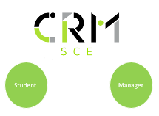
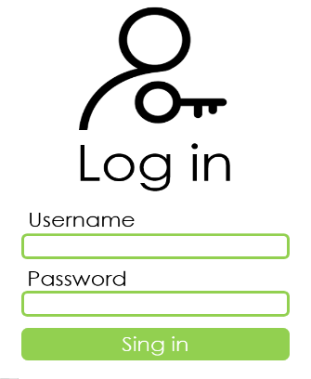
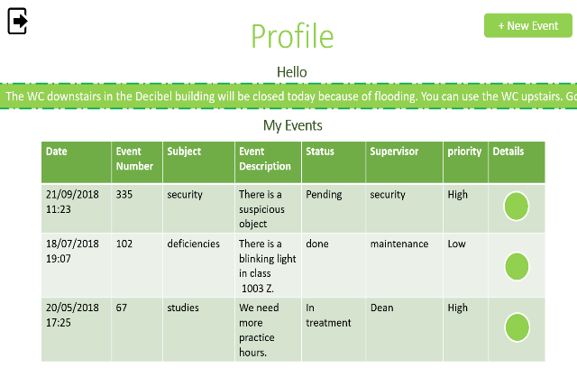

Figure 1 – Home Page. Figure 2 – Log-in Page. Figure 3 – Profile Page.

If the user clicks on 'new event' he/she goes to the New Event page, see Figure 4. In this page the user will need to fill his/her identifying information, like first name, surname, ID number and name Also, the select the event subject, description of the event, and mark it the urgency is high/low, after press the 'Send' bottom the user will receive a successful message.

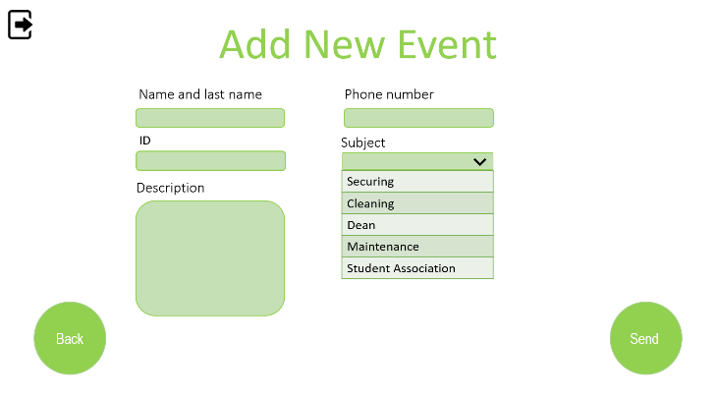

Figure 4 – New Event Page.

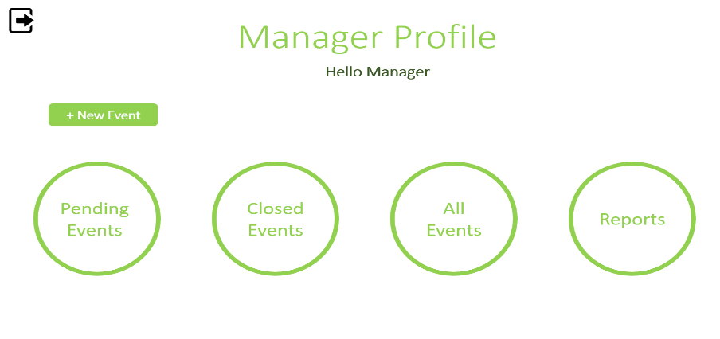
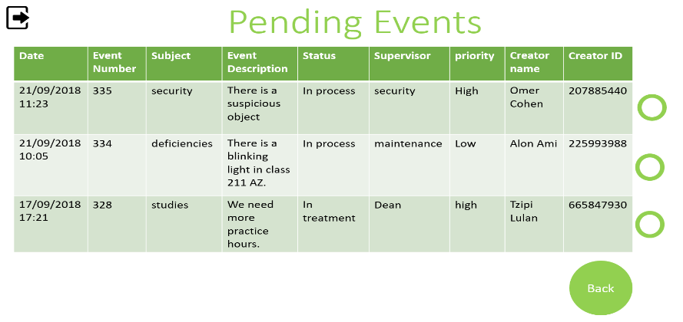
The Software owners and administrators have a different Profile page, see Figure 5. The administrators have access to open a new event and see the incoming events from all the users of this system. This page divine to 4 categories: pending events, closed event, all event, and reports. In the pending events page see Figure 6, the manager can the edit the status, choose the urgency and change the object/supervisor of the event.

Figure 5 – Manager Profile. Figure 6 – Pending Events Page.

In double-click on the event or on the circle beside. The ticket (Event) open for the manager's care and the ststuse automaticlly will change to 'In trearment' when the manager click Save.
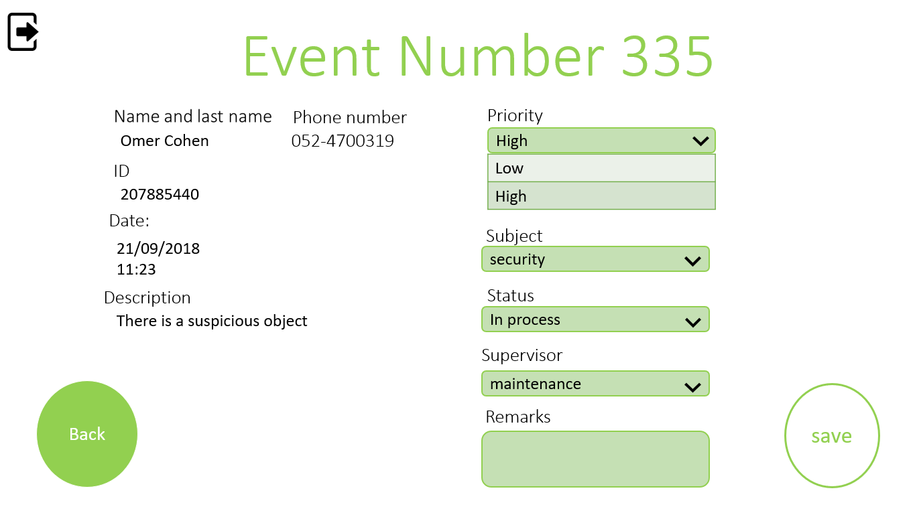

In Figure 7, the manager should see the Closed events.
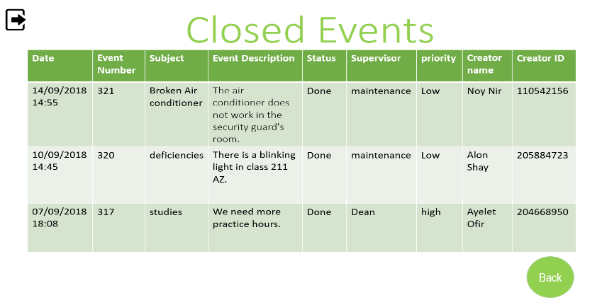
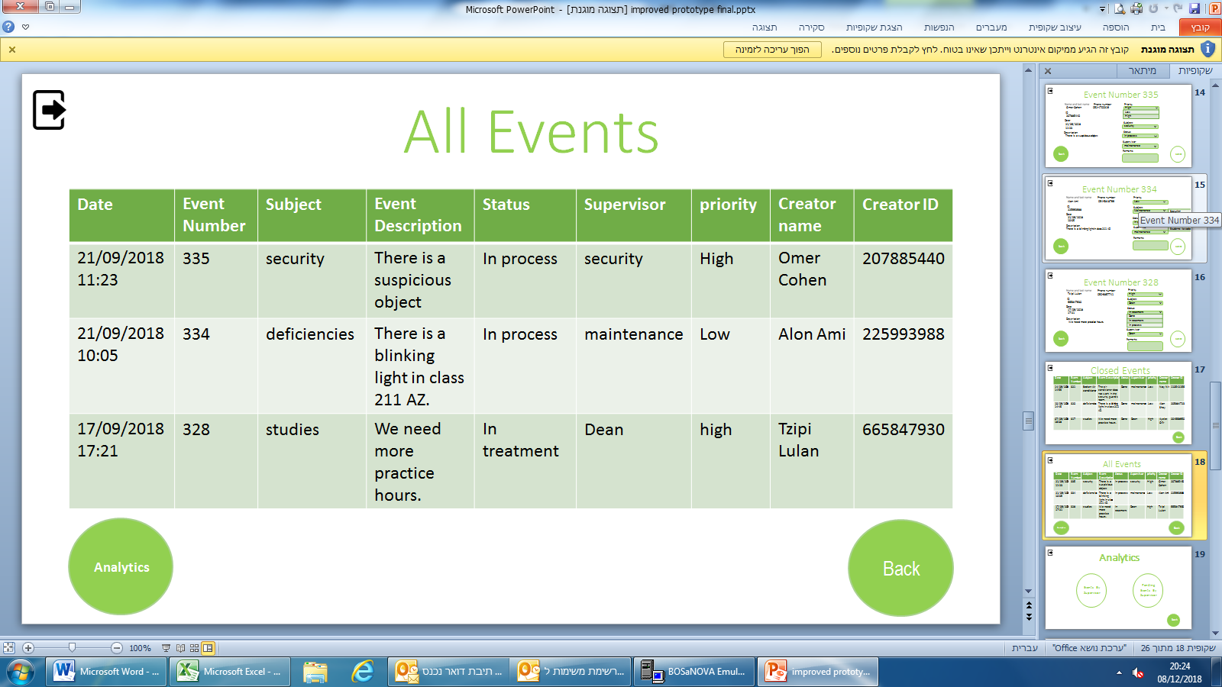
In Figure 8, the manager should see all events that send from all the users of the application, in the left bottom corner by clicks the 'reports' the admin can get option to see all the reports by filleted by 3 categories: events by supervisor and pending events by supervisor, see Figure 9.
Figure 7 – Closed Events Page. Figure 8 – All Events Page.
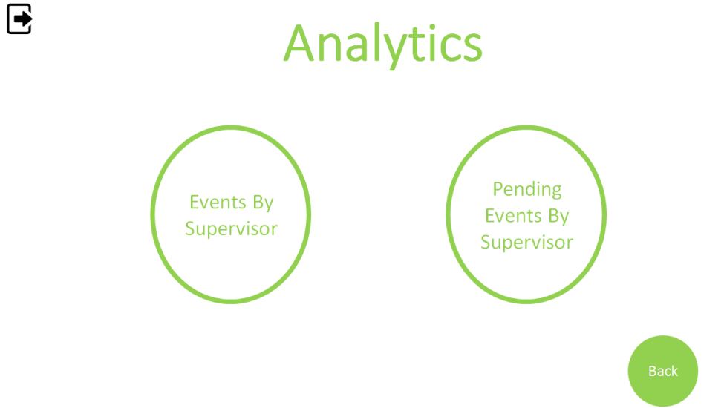

Figure 9 – Reports Page.

The manager can see all the often events that coming into the system, by how many times this event sends and the description of the event.
In Figure 10. The manager can see all the often events that coming into the system, and divided to categories like, security, cleaning service, maintenance, also in Figure 11 he can see the pending events.

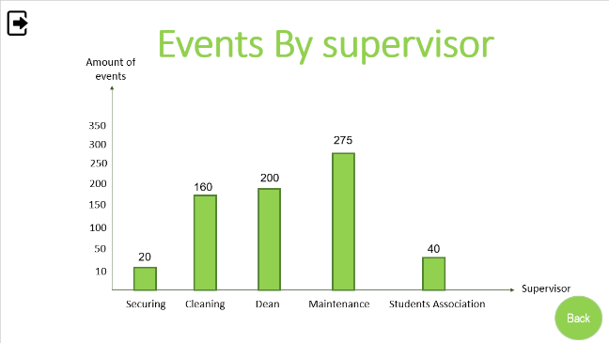

. Figure 10 –Event by Supervisor Page.
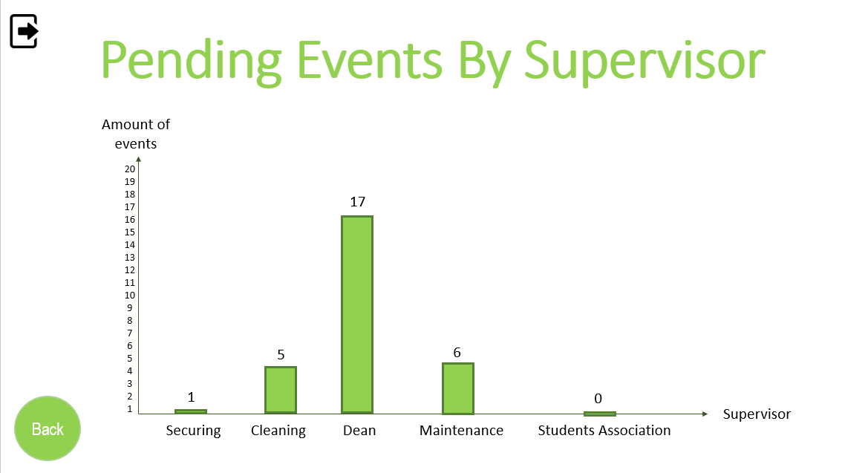

Figure 11 –Pending Events by Supervisor Page.

In the report page, the manager has access to generate a report by choosing the parameters of status, priority, supervisor and date, see Figure 12.
In any page the user has an option to log-out from the application by click the mark on the top left corner.

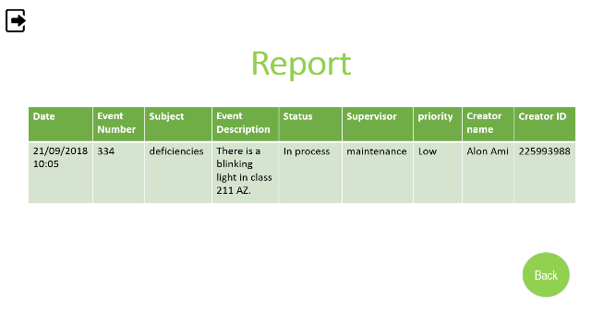



Figure 12 – Report Page. Log – up Icon

Hardware Interfaces
Not necessary, since neither the mobile application nor the web portal have any designated hardware, it does not have any direct hardware interfaces. This application will need keyboard that have in any phone.

Software Interfaces
The mobile application communicates with the database of the academy to get the username to log-in to the application. The system must have ability to work on every operation system's smartphones on every version if its ISO (iPhone) or Android.

Communications Interfaces
The communication between the different parts of the system is important since they depend on each other. This system must have a communication to the database of the academy, since the username that allowed the user to log-in the application came from this database.
The system has a communication between the administration and the staff/students by following the status of the events and see what happening in all the events.

System Features

System Feature 1
4.1 Event submission-
4.1.1 the system receives events via 'New Event' form that are being submitted by verified users located in the database.
4.1.2 all events are being automatically saved and await managers review.
4.1.3 only verified users are permitted access to an event submission, a non-verified users' access to the event page isn't authorized.
the system automatically attaches a date and time to the event with an Event number.
The user's main info is entered at the event page (name, student id etc.)
After choosing the subject (relevant department).
The user fills out the Event description under the appointed department responsible for the subject being reported.
If the 'New Event' form is blank or contains less than a certain amount of characters, the user will receive a notice (warning) stating that fact, so he may either edit the form or leave the page.
The user will label his event with a rank of urgency (high, low) in the priority section.
In a case the user did not rank the event a notice will be printed stating that. The user will modify the rank of the label.
If the event is sent successfully a message will appear stating that fact.
In a case of an unsuccessful submission a message will appear accordingly.
While the event is submitted it appears on the 'previous events' page that could be reached through 'personal profile'.
Closed events will change status to 'done'.

4.2 Managing events-
4.2.1 authorized managers (each department is appointed a manager) receive only events labeled under their department to their 'manager profile' under 'pending events'.
The manager reviews the event and labels it by status.
The Event is closed after the manager decides the event was dealt with.

4.2.2 the manager chooses if the event is relevant or not and determines following actions, such as 'closing' irrelevant events (duplicated events), mislabeled events that require redirection to the appointed department and labeling already treated events as 'done'.

4.2.3 with each submission the appointed manager receives it via 'pending events',
The events are labeled so the manager chooses which events are urgent and which can be treated later on. In a case of mislabeled cases the manager submits the priority (rank) he seems fit.
The manager will change the status of each event accordingly.
(in treatment, in process, done)
The manager will add remarks and additional information that he seems fit at the 'remarks' section.
An event is considered 'done' when the manager decides the issue has been resolved.
Events in process will be seen in the 'treatment' page, the closed(done) events at the 'reports'.

4.3 generating reports

4.3.1 a report can be generated by a manager.
The report gathers all events regarding the specific search specifications entered by the manager.
(events by supervisor, pending events by supervisor)

4.3.2 reports purposes may vary.

4.3.3 generating a new report requires the manager to access 'reports' page through 'manager profile', a page 'reports' contains 3 parameters from which the manager chooses the wanted characteristics.
To generate the report the manager will click on one of the 3 featured choices.
events by supervisor, pending events by supervisor).
Reoccurring events may be found in all events are located in the 'events by supervisor' and the events that are pending are located accordingly.

4.4 analysis

4.4.1 A manager can generate an annalistic review via 'analyze' feature.

4.4.2 analyses are generated for statistical purposes.

4.4.3 only managers permitted to generate analyses.
To generate an analysis the manager enters 'all events' then clicks on the 'analyze' button located below.
In which he'll chose between 2 options (events by supervisor, pending events by supervisor).

Other Nonfunctional Requirements

Performance Requirements
The system is required to provide service (to be accessible, to be online) at all the working hours in the days that college is working, meaning Sunday-Friday from 8 am to 5 pm.
The system should always have a full connection to the college database.
The database should be properly designed and to save each request/event twice- once as the inquiry and for the second time as the ticket that the handler feels in, to provide more reliable database and to assure that no information would get lost.
In additional the system has a report system which provides a summary of the events to the manager, the system does update the summary every 24 hour in order for the manager to have the up to date information.

Safety Requirements
To prevent the failure of the system and the ensuing loss of information, the database of the system, which will contain all the previous inquiries will be backed up online automatically each 24 hours, so in case of failure the system will be restorable.

Security Requirements
Considering the connection between the college databases, the system should be able to log out automatically after certain amount of time without any usage.
The college database provides the full list of the users and the password of each user, so the system will be able to login after verifying a match between a user and the password
To protect the integrity of the system the user will be given 3 times to enter his details correctly, in case of a failure the application closes.

Software Quality Attributes
The system should be user-friendly, it should be clear written, and the information should be reliable and provided swiftly.
The system should be accessible online, making it portable.
In case of any future changes the system should be able to adapt in the future.

Business Rules
Since the system is not a business on its own, It is only an application to provide service to pre-existing business body that is the college that section is irrelevant.

Other Requirements
Not relevant since the previous documents contains the full description of the system.
Appendix A: Glossary
The term "event" - for each request / malfunction / optimization proposal is called an event. Using the event form you can enter the details for the event we are recording.
Appendix B: Analysis Models
At the moment it is irrelevant, will be developed in the future.
Appendix C: To Be Determined List
Each part 6

